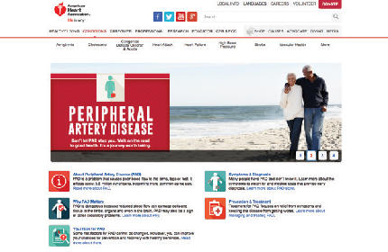

If you do have PAD, special exercise

programs and medications have helped many others like you to manage symptoms and lower risks.

[Visit **www.heart.org/PAD** to learn more.](http://www.heart.org/PAD)

**AN IMPORTANT R E A SON TO**

**TAKE YOUR SOCKS OFF**

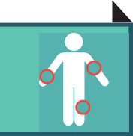

**Peripheral Artery Disease (PAD) affects more than 8.5 million American adults and many are unaware. Are you one of them?**

Proper diagnosis can start by taking off your socks and

talking with your healthcare provider about any symptoms you have noticed.

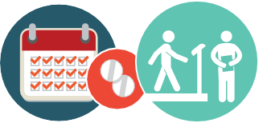

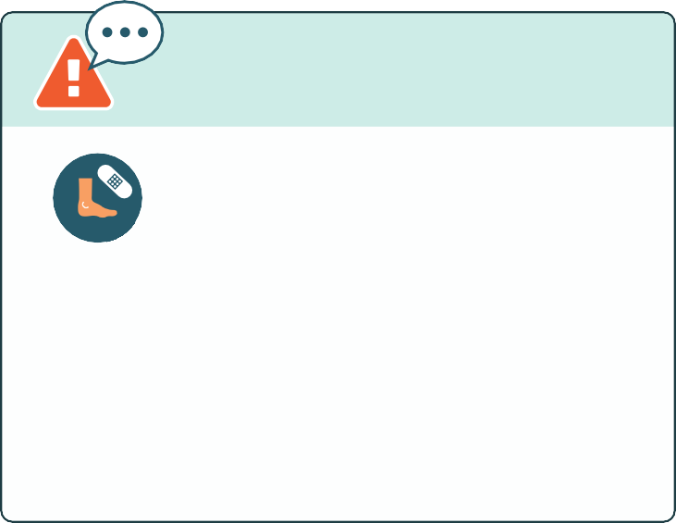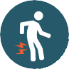

**SYMPTOMS:**

What should I look for?

Leg or foot wounds that are slow to heal

Unexplained leg pain or cramping, especially during exercise or walking

Skin problems or discoloration on your legs and feet,

poor nail growth

**Write down any questions or notes to discuss with your doctor:**

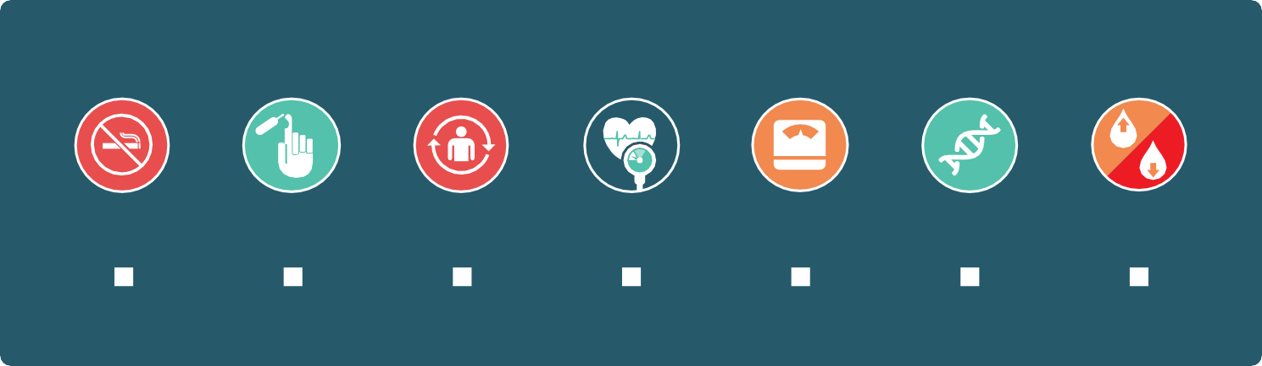

**RISK FACTORS:** People with these risks are more likely to have PAD.

**HDL**

**LDL**

**A history of smoking**

**Diabetes**

**Advanced Age**

**High blood pressure**

**Excess weight**

**A family history High**

**of PAD**

**cholesterol**

Discuss your possible risks for PAD with your healthcare provider.