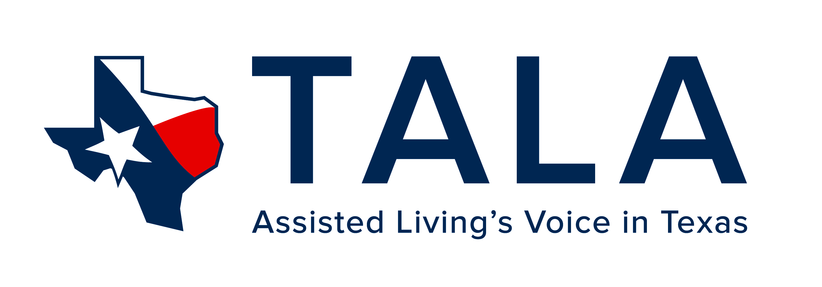

The Texas Assisted Living Association will be recognizing excellence at our Heroes Reception at the 2018 Annual Conference and Trade Show on the evening of April 18th in Galveston.

Do you know of an assisted living hero? Someone who has gone the extra mile or given an award-winning performance? Nominate your Heroes now and let them be recognized during the TALA conference in April in Galveston.

*Complete the form below and return it by fax to (512) 342-2858 or email to Amanda.bailey@tala.org by March 9th*

Award:  Aide/Care Associate  Nurse  Memory Care Specialist
 Executive Director  Chef  Other Staff
❑ Activity Director  Director of Sales/Marketing

Please use a second page as necessary to tell us more about your hero.

Nominee:

Community:

Nominated By:

Reason this individual deserves recognition:

Phone: Email:

